**Object Detection**

2019/08/30

首先陳老師先以一張投影片解釋物件辨識，投影片上有三張照片，最左邊是一張貓的照片，用的是classification，例如辨識貓、狗，中間是一張貓，外圍有一個方框框住貓，除了辨識貓之外，還要找出它的location，最右邊則是有許多的貓、狗，每一隻動物都有一個方框，除了標示出類別，還有正確的位置，用的就是Object detection。

接下來陳老師介紹一些常用的模型，例如R-CNN, Fast RCNN, YOLO.... 等，並介紹one-stage、two-stages的差異，讓大家有一個清楚的概念。

實作階段，陳老師帶來最新的[ImageAI](https://github.com/OlafenwaMoses/ImageAI)，利用這個python套件，6行code就寫完模型訓練，training只需要7行code，強大的威力，令大家嘖嘖稱奇，陳老師也大方的分享程式碼，讓大家在[Google Colab](https://colab.research.google.com/)上實作，感覺它的威力。

===========================================================

**Outline:**

* What is Object Detection?
* Object Detection Algorithms
* Prepare Your Data
* Implementations
* Extras
* Conclusion

=========================

1. **What is object detection?**

Object detection comprises the image classification and localizations.

* Evolution of Object Detection and Localization Algorithms

<https://towardsdatascience.com/evolution-of-object-detection-and-localization-algorithms-e241021d8bad>

[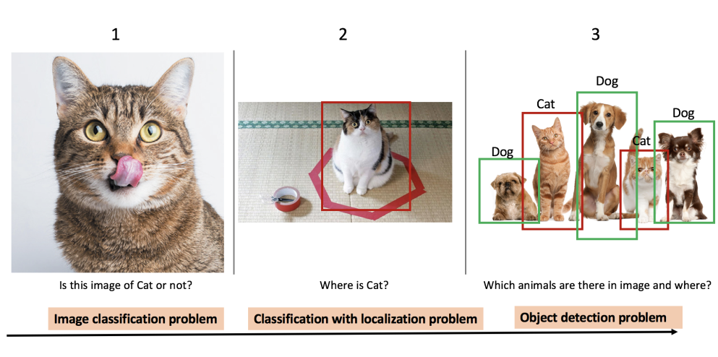](https://miro.medium.com/max/2279/1*cpe4z05DgTJvm0SG0MsrjA.png)

* Other Computer Vision Tasks
  + **Semantic Segmentation** : Pixel-wise classification to identify the class of objects in an image
  + Classification + Localization : Classify and locate a desired object via a bounding box
  + Object Detection : Identify multiple objects and draw bounding boxes around them
  + Instance Segmentation : Similar to Semantic Segmentation but mark (pixel-wise) multiple instances of the same object separately.

[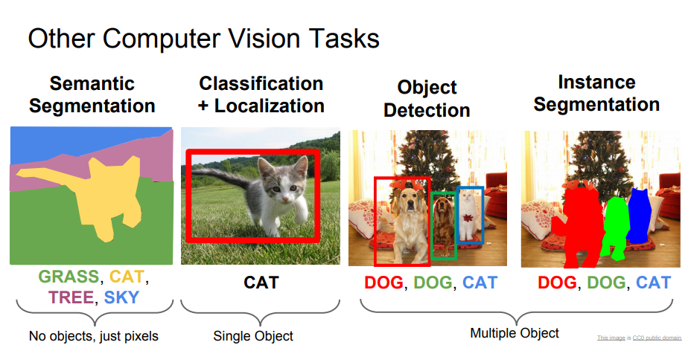](https://miro.medium.com/max/924/1*YwPEETjjgOFHMqHCRD5jbw.png)

Source: cs231n, Lecture 11, Detection and Segmentation (1/05/2018). Available: <http://cs231n.stanford.edu/slides/2018/cs231n_2018_lecture11.pdf>

* Why this problem is important?
* Numerous requirements to face
* Ultrasound medical image and museum items checking

1. **Object Detection Algorithm**

[Object Localization and Detection](https://leonardoaraujosantos.gitbooks.io/artificial-inteligence/content/object_localization_and_detection.html)

[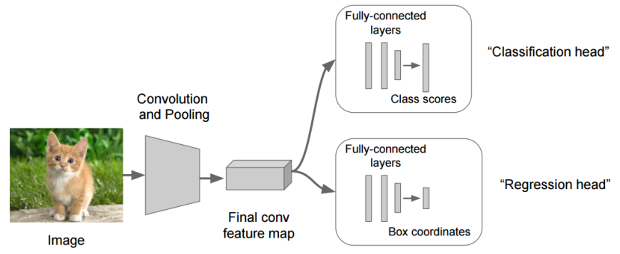](https://leonardoaraujosantos.gitbooks.io/artificial-inteligence/content/more_images/LocalizationRegression2.png)

* R-CNN(Region with CNN) (See: <https://arxiv.org/abs/1311.2524>)
* Fast RCNN(See:<https://arxiv.org/abs/1504.08083>)
* Faster RCNN(See: <https://arxiv.org/abs/1506.01497>)
* R-FCN()
* SSD
* YOLOv1 to YOLOv3
* ReinaNet
* FPN

# (參考: a. [關於影像辨識，所有你應該知道的深度學習模型](https://medium.com/cubo-ai/%E7%89%A9%E9%AB%94%E5%81%B5%E6%B8%AC-object-detection-740096ec4540)’

# b. [R-CNN, Fast R-CNN, Faster R-CNN, YOLO — Object Detection Algorithms](https://towardsdatascience.com/r-cnn-fast-r-cnn-faster-r-cnn-yolo-object-detection-algorithms-36d53571365e))

* Deep Learning for Object Detection: A Comprehensive Review <https://towardsdatascience.com/deep-learning-for-object-detection-a-comprehensive-review-73930816d8d9>

[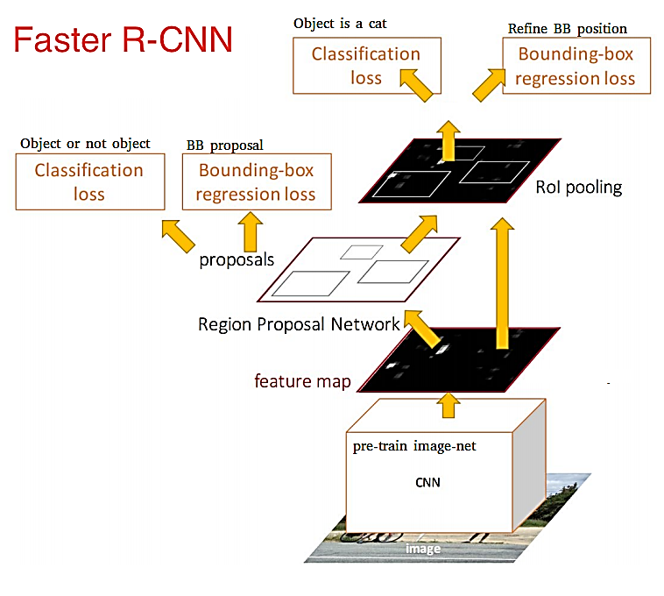](https://miro.medium.com/max/853/1*LHk_CCzzfP9mzw280kG70w.png)

[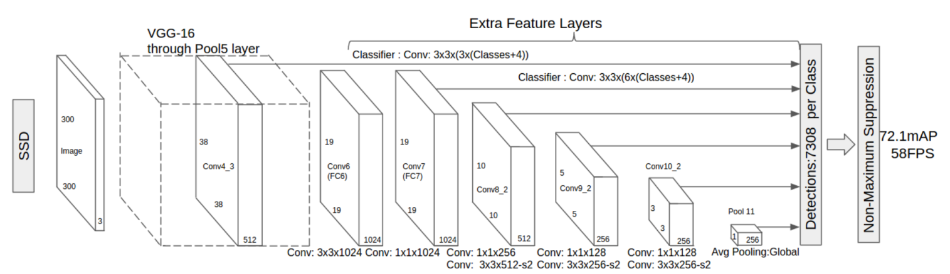](https://miro.medium.com/max/2201/1*p-lSawysBsiBzlcWZ9_UMw.png)

* one stage and two stages

([深度學習-什麼是one stage，什麼是two stage 物件偵測](https://medium.com/@chih.sheng.huang821/%E6%B7%B1%E5%BA%A6%E5%AD%B8%E7%BF%92-%E4%BB%80%E9%BA%BC%E6%98%AFone-stage-%E4%BB%80%E9%BA%BC%E6%98%AFtwo-stage-%E7%89%A9%E4%BB%B6%E5%81%B5%E6%B8%AC-fc3ce505390f)

[Optimizing the Trade-off between Single-Stage and Two-Stage Deep Object Detectors using Image Difficulty Prediction PDF](https://arxiv.org/pdf/1803.08707.pdf))

* Comparison
* YOLOv3 is good as mAP and time
  + What’s new in YOLO v3?

<https://towardsdatascience.com/deep-learning-for-object-detection-a-comprehensive-review-73930816d8d9> (<https://pjreddie.com/media/files/papers/YOLOv3.pdf>)

[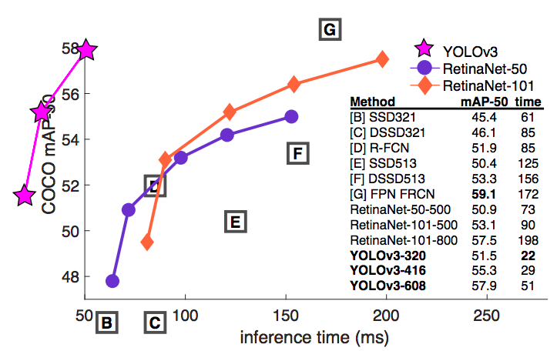](https://miro.medium.com/max/813/1*YpNE9OQeshABhBgjyEXlLA.png)

YOLO vs RetinaNet performance on COCO 50 Benchmark

* YOLO3: A Huge Improvement

<https://mc.ai/yolo3-a-huge-improvement/>

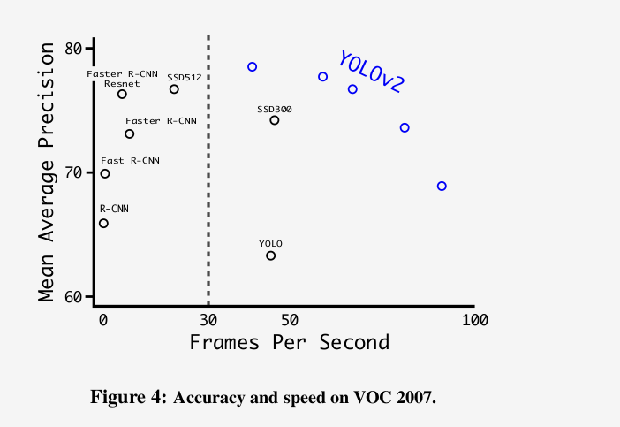

Accuracy and speed tradeoff on VOC 2007 (Source: YOLOv2 paper)

1. Prepare Your Data

* Labelme <https://github.com/wkentaro/labelme>

其他安裝文章: <https://www.itread01.com/content/1544810780.html>

1. **Implementations**

a. Implementations: Train XML annotations

b. Implementations: Training

c. Implementations: Testing

Make a copy of [IMAGEAI-ObjectDetectionTrain-HoloLens.ipynb](https://colab.research.google.com/drive/1-p-yR5fF26UEECnYDDCSFhkHjX0Ve0R-?fbclid=IwAR2eIBG_R-76hc-rqaVihIZl4FH06cMPuVAHCiN8ffTURsPKpmuz9_pkSyA) for testing.

<https://github.com/OlafenwaMoses/ImageAI/releases/download/essential-v4/pretrained-yolov3.h5>

|  |
| --- |
| **From** imageai.Dectection.custom **import** DetectionMode  trainer = DetectionModelTrainer()  trainer.setModelTypeAsYOLOv3()  trainer.setDataDirectory(data_directory="hololens")  … |

* **Colab example**: tensorflow-object-detection-training-colab.ipynb <https://colab.research.google.com/github/Tony607/object_detection_demo/blob/master/tensorflow_object_detection_training_colab.ipynb?hl=en>

Make a copy and test!

1. **Extras**
   * Run SSD, Faster RCNN and FCN
   * <https://medium.com/swlh/how-to-train-an-object-detection-model-easy-for-free-f388ff3663e>
   * (Or <https://www.dlology.com/blog/how-to-train-an-object-detection-model-easy-for-free/> )
2. **Conclusions**
   * The impact of the object detection
   * YOLO3 is agreat framework so far
   * Implementation is quite easy now
   * Labeling job is quite laborious, we are working on some tricks

**===========**

**Reference:**

* **ImageAI (v2.1.4)**

<https://github.com/OlafenwaMoses/ImageAI>

* **Train Object Detection AI with 6 lines of code (Part_I)** <https://medium.com/deepquestai/train-object-detection-ai-with-6-lines-of-code-6d087063f6ff>
* **Object Detection with 10 lines of code (Part_II)**

<https://towardsdatascience.com/object-detection-with-10-lines-of-code-d6cb4d86f606>

* + **Evolution of Object Detection and Localization Algorithms**  <https://towardsdatascience.com/evolution-of-object-detection-and-localization-algorithms-e241021d8bad>
  + **Object Localization and Detection** <https://leonardoaraujosantos.gitbooks.io/artificial-inteligence/content/object_localization_and_detection.html> <https://medium.com/%E8%B3%87%E6%96%99%E9%9A%A8%E7%AD%86/machine-learning-103-d81ef2ad3597>